**ASSIGNMENT-1**

**SDLC: SOFTWARE DEVELOPMENT LIFE CYCLE:**

1. Prototype Model

2. Iterative Model

3. Spiral Model

4. Rapid Application Development Model

**1. Prototype Model**:

The prototype model is a system development method. A prototype model is a involves buildings, testing, and improving a prototype until it means exception.

Prototype model is a tested and refined as per customer needs.

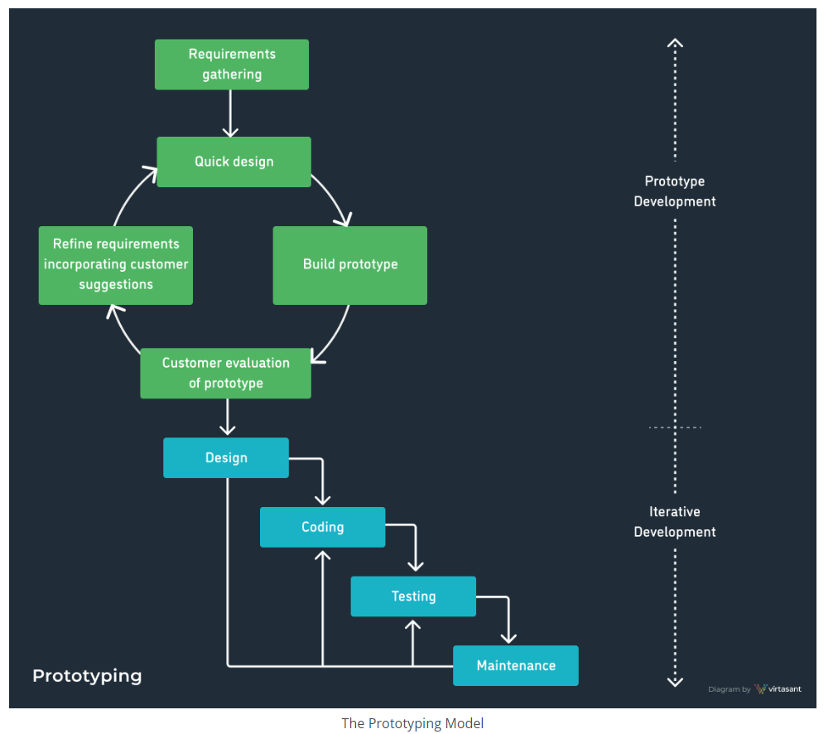

**2. Iterative Model:**

The iterative model is a breakdown projects into smaller, manageable chunks called iteration.

Each iteration involves planning, analysis, design, development, testing, and deployment.

Iterative model is a includes the main phases:

Design, prototype and planning.

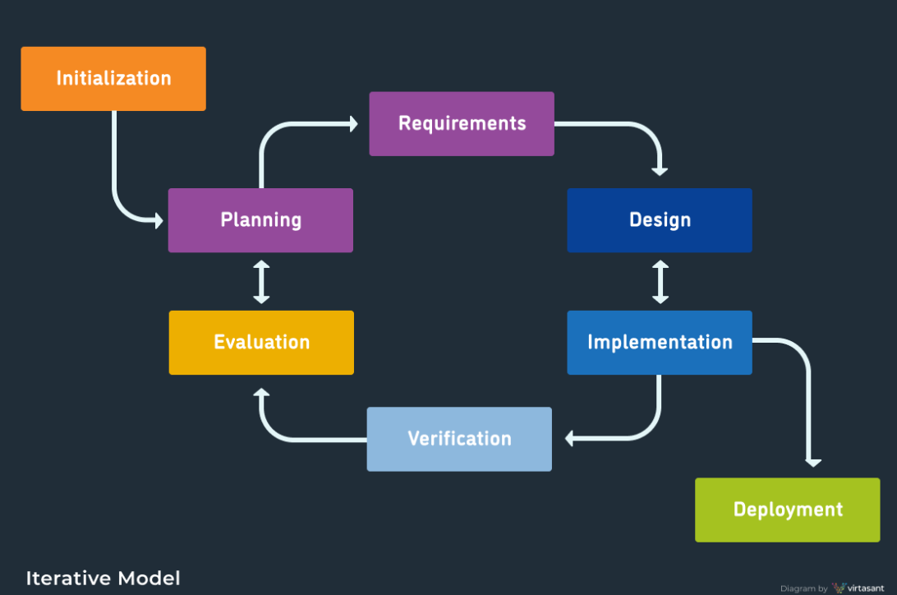

**3. Spiral Model:**

The spiral model is software development life cycle method. A spiral model is a combines the iterative development model with elements of the waterfall model. Spiral model overcome drawbacks of waterfall model.

These model includes the main phases: Planning, risk analysis, product development and planning.

In every cycle new software will be released to customer

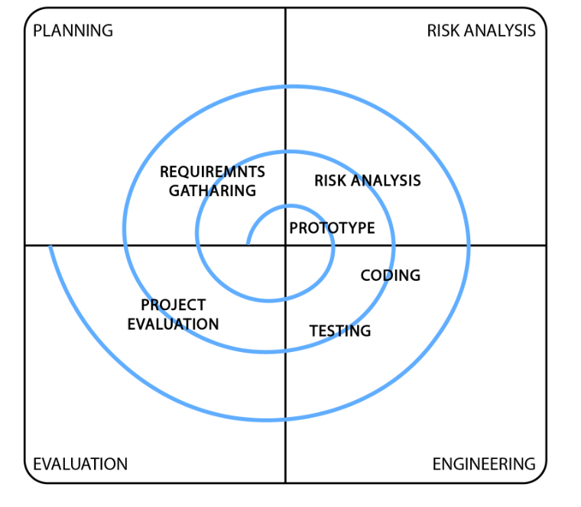

**4. Rapid Application Development Model:**

The rapid development application model is a reduction in planning to focus on highly iterative design and construction process. This model used for reducing the time and cost.

This model includes the phases:

Business modelling, data modelling, process modelling, application modelling and testing and turnover.

